**Drill 1: Git and GitHub Basics**

**Objective:**

Set up a private GitHub repository for the Data Science Specialization, organize it with folders for all courses (including **.gitkeep** files for empty folders), and use **GitHub Desktop** to manage and push changes to the repository. Learn how to structure commit messages appropriately.

**Instructions:**

1. **Create a GitHub Repository Online**:
   * Log in to your GitHub account.
   * Create a new repository with the following details:
     1. **Repository Name**: data-science-specialization.
     2. **Description**: "This repository contains all assignments, drills, and projects for the Johns Hopkins Data Science Specialization on Coursera.".
     3. **Visibility**: Set the repository to **Private**.
     4. **License**: Select the **Creative Commons Zero v1.0 Universal (CC0 1.0)** license.
     5. **Initialize Repository**: Check the box to include a README.md file.
     6. Leave .gitignore as **None**.
2. **Clone the Repository Locally Using GitHub Desktop:**
   * Open **GitHub Desktop**.
   * Use the **File > Clone Repository** option.
   * Select the repository you just created (data-science-specialization).
   * Choose a local folder on your computer where the repository will be cloned.
   * Create Course Folders with **.gitkeep** files:
     + Navigate to the cloned repository folder on your local computer.
     + Inside the repository, create subfolders for all 10 courses in the specialization using the **exact names** below:

01-the-data-scientists-toolbox

02-r-programming

03-getting-and-cleaning-data

04-exploratory-data-analysis

05-reproducible-research

06-statistical-inference

07-regression-models

08-practical-machine-learning

09-developing-data-products

10-data-science-capstone

* For each folder, add a **.gitkeep** file to ensure it is tracked by Git:
  1. Open each folder.
  2. Open Notepad and create a blank file by saving the file as " .gitkeep " (with the quotes) as the file name. This will save the file without an extension in Windows.

1. **Create and Save the First Drill File:**:
   * Navigate to the folder named **01-the-data-scientists-toolbox**.
   * Create a subfolder named **drills** within this folder to store your work for this drill.
   * In the 01-the-data-scientists-toolbox/drills folder, create a text file named hello_world.txt.
   * Add the following text to the file:

*My journey in Data Science starts here!*

* + Save the file.

1. **Use GitHub Desktop to Upload Changes**:
   * Open GitHub Desktop and ensure it is pointing to your cloned repository.
   * **Stage the changes**:
     + GitHub Desktop will show all the new folders, **.gitkeep files**, and the **hello_world.txt** file as "Uncommitted Changes.".
     + Review the changes to ensure they match your expectations.
   * Write a Commit Message
     + **Summary (First Line)**: A concise description of the changes, **50 characters or fewer**. For this commit insert the following:

‘*The Data Scientist's Toolbox - Added hello_world.txt and .gitkeep files’*

* + - **Longer Message (Optional)**: A detailed explanation of the changes, describing why they were made or any additional context. For this commit insert the following:

**‘***Created the folder structure for all courses in the specialization, added .gitkeep files to track empty folders, and added the hello_world.txt file to the drills subfolder. This ensures the repository is ready for future course-related files.***’**

* + Commit the changes locally.
  + Use the **Push Origin** button in GitHub Desktop to upload the changes to your online repository.

1. **Verify and Submit**:
   * Log in to your GitHub account and verify that your repository now includes the following structure:

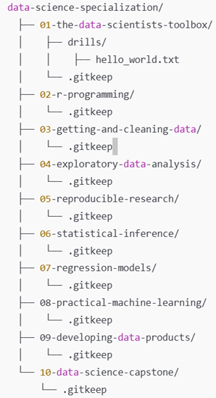

* + Submit the **URL to your GitHub repository** for grading.

**Important Notes:**

1. **No Use of ChatGPT**:
   * All work must be completed independently without the assistance of AI tools like ChatGPT.
2. **No Collaboration**:
   * Do not discuss or share solutions with peers. Every submission must be your own.
3. **Grading Criteria**:
   * Repository structure:
     + All course folders are correctly named and organized as per the instructions.
   * Drill folder and file:
     + The hello_world.txt file is located in the correct folder (01-the-data-scientists-toolbox/drills).
   * Commit history:
     + Commit messages are clear, relevant, and meaningful.
   * Push confirmation:
     + All changes are pushed to GitHub, and the repository is accessible.